Bahria University,

Karachi Campus



LAB EXPERIMENT NO.

_______3_______

LIST OF TASKS

|  |  |
| --- | --- |
| TASK NO | OBJECTIVE |
| 1 | **Login Page Application using Relative Layout.** |
| 2 | **Calculator Application using both Relative and Constraint Layout.** |
| 3 | **Food Ordering Application using Constraint Layout.** |

Submitted On:

___________

(Date: 02/04/23)

**LAB# 03**

**Task # 1: Login Page Application using Constraint Layout.**

**Solution:** *<?***xml version="1.0" encoding="utf-8"***?>*<**androidx.constraintlayout.widget.ConstraintLayout xmlns:android="http://schemas.android.com/apk/res/android"  
 xmlns:app="http://schemas.android.com/apk/res-auto"  
 xmlns:tools="http://schemas.android.com/tools"  
 android:layout_width="match_parent"  
 android:layout_height="match_parent"  
 tools:context=".MainActivity"**>  
  
 <**TextView  
 android:id="@+id/textView3"  
 android:layout_width="wrap_content"  
 android:layout_height="wrap_content"  
 android:layout_marginBottom="28dp"  
 android:text="UserName"  
 android:textColor="@color/colorPrimaryDark"  
 android:textSize="17dp"  
  
 app:layout_constraintBottom_toTopOf="@+id/editText"  
 app:layout_constraintEnd_toEndOf="parent"  
 app:layout_constraintHorizontal_bias="0.287"  
 app:layout_constraintStart_toStartOf="parent"** />  
  
 <**Button  
 android:id="@+id/button"  
 android:layout_width="wrap_content"  
 android:layout_height="wrap_content"  
 android:layout_marginBottom="228dp"  
 android:text="Button"  
 android:background="@color/colorPrimaryDark"  
 android:textColor="#FFFFFF"  
 app:layout_constraintBottom_toBottomOf="parent"  
 app:layout_constraintEnd_toEndOf="parent"  
 app:layout_constraintHorizontal_bias="0.498"  
 app:layout_constraintStart_toStartOf="parent"** />  
  
</**androidx.constraintlayout.widget.ConstraintLayout**>

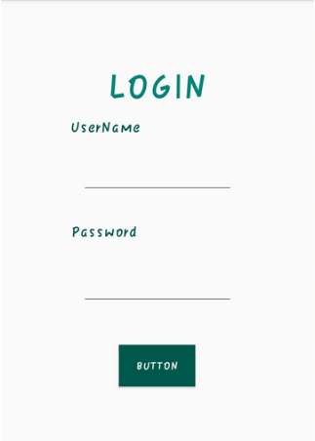**Output:**

**Task # 02: Implement the design given below by using LinearLayout.**

**Solution& Output:**

**XML CODE:**

*<?***xml version="1.0" encoding="utf-8"***?>*

<**LinearLayout xmlns:android="http://schemas.android.com/apk/res/android"**

**xmlns:app="http://schemas.android.com/apk/res-auto"**

**xmlns:tools="http://schemas.android.com/tools"**

**android:layout_width="match_parent"**

**android:layout_height="match_parent"**

**tools:context=".MainActivity"**

**android:orientation="vertical"**>

<**LinearLayout**

**android:layout_width="match_parent"**

**android:layout_height="wrap_content"**

**android:orientation="horizontal"**

**android:layout_weight="2"**>

</**LinearLayout**>

<**LinearLayout**

**android:layout_width="match_parent"**

**android:layout_height="wrap_content"**

**android:orientation="horizontal"**

**android:layout_weight="1"**>

<**Button**

**android:layout_width="wrap_content"**

**android:layout_height="match_parent"**

**android:text="+"**

**android:textSize="20sp"**

**android:layout_weight="1"**/>

</**LinearLayout**>

<**LinearLayout**

**android:layout_width="match_parent"**

**android:layout_height="wrap_content"**

**android:orientation="horizontal"**

**android:layout_weight="1"**>

</**LinearLayout**>

<**LinearLayout**

**android:layout_width="match_parent"**

**android:layout_height="wrap_content"**

**android:orientation="horizontal"**

**android:layout_weight="1"**>

<**Button**

**android:layout_width="wrap_content"**

**android:layout_height="match_parent"**

**android:text="*"**

**android:textSize="20sp"**

**android:layout_weight="1"**/>

</**LinearLayout**>

**OUTPUT:**

**Task # 3: Food Ordering Application using Constraint Layout.**

**Solution& Output:**

